**Objective**

In this final assignment, you will:Create a Jupyter Notebook Insert code and markdown cells Share your notebook through GitHub

**Instructions**

**Note - Screenshots**

Throughout this lab, you will be prompted to take screenshots and save them on your device. You will need these screenshots to upload them as your submission for peer review at the end of this course. You can use various free screengrabbing tools or your operating system's shortcut keys to do this (for example, **Alt+PrintScreen** in Windows and **Shift+Command+3** for Mac).

**Exercise 1: Create a Jupyter Notebook**

Create a new Jupyter notebook called **DataScienceEcosystem.ipynb**

*Note: The next item in the course will launch JupyterLite with an empty notebook with this name that you can use to complete rest of the Exercises. You can also use any other Jupyter notebook environment (e.g. Anaconda) that you prefer to complete the assignment.***Exercise 2: Create markdown cell with title of the notebook**

Create a markdown cell with the title Data Science Tools and Ecosystem using H1 style heading.  
***Take a screenshot of the markdown cell and name it as 2-title.png (Images can be saved with either the .jpg or .png extension.)***  
**Exercise 3 - Create a markdown cell for an introduction**

Write an introductory sentence about the notebook such as the follows:

In this notebook, Data Science Tools and Ecosystem are summarized.  
***Take a screenshot of the markdown cell and name it as 3-intro.png (Images can be saved with either the .jpg or .png extension.)***  
**Exercise 4 - Create a markdown cell to list data science languages**

Start the cell with an overview line such as:

Some of the popular languages that Data Scientists use are:  
Then create an ordered list (i.e. numbered) listing 3 (or more) commonly used languages for data science.***Take a screenshot of the markdown cell and name it as 4-dslanguages.png (Images can be saved with either the .jpg or .png extension.)***

**Exercise 5 - Create a markdown cell to list data science libraries**

Add an overview line to the cell like:

Some of the commonly used libraries used by Data Scientists include:  
Below this line add an ordered list listing 3 (or more) commonly used libraries in data science.  
***Take a screenshot of the markdown cell and name it as 5-dslibraries.png (Images can be saved with either the .jpg or .png extension.)***  
  
  
**Exercise 6 - Create a markdown cell with a table of Data Science tools**

Create a single column table in this cell with the first row containing the header Data Science Tools. The subsequent three rows in the table should indicate three development environment open source tools used in data science.

***Take a screenshot of the markdown cell and name it as 6-dstools.png (Images can be saved with either the .jpg or .png extension.)***  
*Hint: Refer to*[***Lab: Using Markdowns in Jupyter Notebooks***](https://www.coursera.org/learn/ibm-open-source-tools-for-data-science/ungradedLti/08qsY/hands-on-lab-using-markdown-in-jupyter-notebooks?utm_medium=Exinfluencer&utm_source=Exinfluencer&utm_content=000026UJ&utm_term=10006555&utm_id=NA-SkillsNetwork-Channel-SkillsNetworkCoursesIBMDeveloperSkillsNetworkDS0105ENSkillsNetwork984-2022-01-01)*to create a table.*  
  
**Exercise 7 - Create a markdown cell introducing arithmetic expression examples**

Add a line in this cell with H3 style heading with text like:

Below are a few examples of evaluating arithmetic expressions in Python.  
***Take a screenshot of the markdown cell and name it as 7-introarithmetic.png (Images can be saved with either the .jpg or .png extension.)***

**Exercise 8 - Create a code cell to multiply and add numbers**

In this code cell evaluate the expression (3*4)+5.  
*Insert a comment line before the expression to explain the operation e.g.  This a simple arithmetic expression to mutiply then add integers.*  
Then execute the cell to ensure the expression returns the expected output of 17.  
***Take a screenshot of the code cell with output and name it as 8-multiplyandaddintegers.png (Images can be saved with either the .jpg or .png extension.)***

**Exercise 9 - Create a code cell to convert minutes to hours**

In this code cell write an expression that converts 200 minutes into hours.  
*Insert a comment line before the expression to explain the operation e.g.  This will convert 200 minutes to hours by diving by 60.*  
Run the cell to evaluate the expression.  
***Take a screenshot of the code cell with output and name it as 9-hourstominutes.png (Images can be saved with either the .jpg or .png extension.)***

**Exercise 10 - Insert a markdown cell to list Objectives**

Below the introduction cell created in Exercise 3, insert a new markdown cell to list the objectives that this notebook covered (i.e. some of the key takeaways from the course). In this new cell start with an introductory line titled: Objectives: in bold font. Then using an unordered list (bullets) indicate 3 to 5 items covered in this notebook, such as List popular languages for Data Science.  
***Take a screenshot of the markdown cell and name it as 10-objectives.png (Images can be saved with either the .jpg or .png extension.)***

**Exercise 11 - Create a markdown cell to indicate the Author's name**

In this markdown cell markdown cell include the following text Author in H2 style heading. Include your name as regular text below the word Author.  
***Take a screenshot of the markdown cell and name it as 11-authordetails.png (Images can be saved with either the .jpg or .png extension.)***

*Note: Save and download the notebook.*

**Exercise 12 - Share your notebook through GitHub**

Upload your notebook to a public respository on **GitHub**.

*Note : Please keep the****GitHub repo link****of the notebook handy.  
You will need to submit this link as a part of the assignment evaluation.*

*Hint: Refer to*[***Lab: Working with files in Jupyter Notebooks***](https://www.coursera.org/learn/ibm-open-source-tools-for-data-science/ungradedLti/UQsEm/hands-on-lab-working-with-files-in-jupyter-notebooks?utm_medium=Exinfluencer&utm_source=Exinfluencer&utm_content=000026UJ&utm_term=10006555&utm_id=NA-SkillsNetwork-Channel-SkillsNetworkCoursesIBMDeveloperSkillsNetworkDS0105ENSkillsNetwork984-2022-01-01)*to download the notebook from****SN Labs****.*

**Exercise 13 -Take a screenshot of the first page of the notebook and save it as 1-notebook.png(Images can be saved with either the .jpg or .png extension.)**

*Refer to*[***Hands-on Lab: Getting Started with GitHub***](https://cf-courses-data.s3.us.cloud-object-storage.appdomain.cloud/IBMDeveloperSkillsNetwork-DS0105EN-SkillsNetwork/labs/Module2/GitHub1_Getting_Started.md.html)*to upload the downloaded notebook to****GitHub****.*

Congratulations on completing this project. In a subsequent item in the course you will submit a link to your notebook on GitHub and evaluate your peers.

**Introduction to Watson Studio**

Welcome to Introduction to Watson Studio. After watching this video, you will be able to explain what Watson Studio is for and who uses it, list the components of IBM Cloud Pak for Data, find common resources in Watson Studio and IBM Cloud Pak for Data, and build models and manage services and integrations. Watson Studio is a collaborative platform for the data science community. Data Analysts,

Data Scientists, Data Engineers, Developers and Data Stewards all use Watson Studio to analyze data and construct models. With Watson Studio, you can create projects to organize data connections,

data assets, and Jupyter notebooks. You can upload files to your project, and you can clean and shape the data to refine it for analysis. You can then create and share data visualizations via dashboards without using any coding, Watson Knowledge Catalog provides a secure enterprise catalog management platform to deliver trusted and meaningful data. and Watson Machine Learning offers tools and services to build, train, and deploy machine learning models. Cloud Pak for Data as a Service is a secure, seamless data access and integration platform that enables a single view of the data, no matter how many data sources you are working with. It includes IBM Watson Studio, IBM Watson Knowledge Catalog, and IBM Watson Machine Learning and more. In IBM Cloud Pak for Data, you can find step-by-step tutorials that show how to integrate data from multiple sources, build, deploy, test, and more. You can create collaborative data workspaces called Projects where your team can perform

tasks for data science, data engineering, data curation, or machine learning and AI. And you can read Cloud Pak for Data news and updates. As you scroll down, you will see your work highlights, recent activities, and shortcuts. The Quick start section has links to get you started, and the navigation menu is on the upper left. In the navigation menu, Projects shows projects and jobs you have created.

In Deployments, you can train, deploy, and manage machine learning models in collaborative deployment spaces. In Services, you can view different services associated with your account,

and explore the catalog. and Gallery shows a collection of data sets, notebooks, industry accelerators, and sample projects. Now, on the Gallery page, you can search for projects and filter your search by clicking All filters You can filter by format and topics. You can then explore different project types.

and you can also explore the data. Once you select the project, you will see the notebook, when it was last modified, the problem statement, and more. You can Add to your project or download the notebook to your system. One of the core services in Cloud Pak for Data, Watson Studio architecture is centered around the project. To create a project, select Work with data from the Cloud Pak for Data homepage. The Create a project popup will appear with options to create an empty project or create a project from a sample or file. Now when you click, Create an empty project, this page loads. Here you can manage all your projects. Use the context information and actions menu from anywhere in the project to view project information or load data files as assets. The RStudio integrated development environment (IDE) is included with IBM Watson Studio so you can use R notebooks and scripts in your projects. Launch RStudio from the Launch IDE menu after you create a project. The Overview page keeps you up to date with recent assets you created, the resource usage of the project, a readme for your project description, and a project history. To find project assets, click the Assets tab. The New Assets button lets you use data and tools to create analytical assets, like flows, visualizations, experiments, or notebooks, and the Import Asset button lets you import assets. A job is a way of running assets, such as Data Refinery flows or Notebooks in a project. Under the Jobs tab, you can run a job immediately or schedule a job. You can manage your projects under the Manage tab. There you can control access with user groups, define environments and monitor active runtimes, see resource usage, and tools and processing power using Services and integrations. In Service & Integration, you can associate IBM Cloud services with your project to add tools, environments, and capabilities.

And you can also use third-party Integrations so your project can interact with external tools. For example, you can integrate with a Git repository to export the project, work with documents and notebooks in JupyterLab, or back up the project. From the Asset tab, you can use graphical builders, like: Dashboards Editor, to create a sharable visualization in the dashboard, or Data Refinery to create flows to refine data. Decision Optimization has the Decision Optimization model builder to solve scenarios, and with SPSS Modeler, you can quickly develop predictive models and deploy them into business operations to improve decision-making. The New asset tool type options also include

Code editors, which provides a Jupyter notebook editor where you can analyze data or build models.

A Jupyter notebook is a web-based environment for interactive computing. You can use notebooks to run small pieces of code that process your data, and you can immediately view the results of your computation. Now, this Jupyter notebook editor is largely used for interactive, exploratory data analysis programming and data visualization. You should use it if you are new to Jupyter notebooks.

In this video, you learned that Watson Studio is a helpful tool for: analyzing and viewing data,

cleaning and shaping data, embedding data into streams, and creating, training, and deploying.

Learning Watson Studio promotes career growth. Learning Watson Studio is easy and requires no special skills. And Watson Studio offers many available resources.

**Optional: Creating an account on IBM Watson Studio**

Welcome to Creating an IBM Cloud Account and a Watson Studio service. After watching this video, you will be able to create an IBM Cloud account create an IBM Watson Studio service, and create a project in Watson Studio. To create an IBM Cloud account, go to the IBM Cloud registration page. Enter your Email and Password, and then click Next. Verify your email using the 7-digit code sent to the email address you entered, then click Next. So, once your email is successfully verified, enter your first name,

last name, and country or region, then click Next. Review the Account Notice, opt in for email updates if you desire, and accept the terms and conditions, then click Continue. Review the privacy notice and accept it. Click Continue to create the account. It will take a few seconds to create and set up your account. Now, in the apply code section, you will see that the feature code has been applied to your account; click the Create account button to continue. It may take a few minutes to create your account.

So, once your IBM Cloud account is created, you will see the IBM Cloud dashboard.

To use the Watson Studio service, click the Catalog option. Scroll down and select AI/Machine Learning. Then select Watson Studio. This will load the Watson Studio creation page. Here, select Dallas or London under the location option. To avoid any charges, select the lite plan, then accept the license agreements, and click the Create button. Then click Launch in IBM Cloud Pak for Data. Provide a company name and phone number, and select the contact options you prefer. Then click Continue. On the next screen, click Go to the IBM Watson Studio. You have successfully created an account for IBM

Watson Studio and are ready to use the Watson service.Now, let’s start creating a project: click Work with data. You can either create an empty project or create a project from a sample or file. In this video, we will create an empty project. Provide the project name and description, then click Add to select a storage service. You will be redirected to a new page where you will create a Cloud Object Storage.

Scroll down and select the Lite plan, then click Create. Once created, you will be redirected to the previous page. Notice the Refresh option is enabled. Click Refresh to refresh the object storage. Now, your cloud object storage is visible, and the Create option is enabled. Click Create to create a project.

It will take a few seconds to create a project. Once created, the project looks like this. The next video will show you how to add a notebook to the project. So, without further delay, let's begin exploring the Watson Studio. In this video, you learned that: You must create an IBM Cloud account to use Watson Studio. You can get to Watson Studio by clicking Catalog on the IBM Cloud dashboard and then

AI/Machine Learning. You can create an empty project or a project from a sample or file by selecting the Work with data option. And you can add a storage service by selecting Add and then selecting the storage service of your choice

**Jupyter Notebooks in Watson Studio - Part 1**

Welcome to “Jupyter Notebooks in Watson Studio – Part 1”. After watching this video, you will be able to create a Jupyter Notebook and load a data file, share a Jupyter Notebook with others, and

create a job and schedule it to run. In the previous video, you learned how to create a project. Once created, you will see this page. Click New asset to add or create a new notebook. Under Tool type, select Code editors and then, select Jupyter notebook editor to create a new notebook. On the New Notebook page, you can create a blank notebook, upload a notebook file from your file system, or upload a notebook file from a URL. In this video, we will create a blank notebook. First, provide a notebook name and description.You need to specify the runtime environment for the language you

want to use (for example, Python, R, or Scala). Then click Create to create a notebook.After you create a notebook, you will upload the data. Make sure the data you load, and the code commands you use to analyze that data, both match the kernel/runtime language you selected when you created your notebook. To upload the data, click Find and Add Data. In the Data pane, browse for the files or drag them onto the pane. You must stay on the page until the upload is complete. You have the option to cancel an ongoing upload process if need be. Now, the data is available to work on. Click Insert to code and select pandas DataFrame. It's a best practice to insert a cell at the top of the Jupyter notebook using the Insert Cell Above option from the Insert tab. Now, a cell is added. Now, change the cell type to markdown, so this cell will not be treated as code. In the markdown cell, describe what the notebook does and run it. Now you're ready to run the notebook. The inserted code loads the data set into a data frame. Run the code cell to display the first five rows of the data set. From the File tab, select the Save Version option to save the latest changes in the notebook. Click the project name to return to the project home page.Back on the project home page, under the Assets tab, select the Source Code tab in the left navigation pane, you’ll find the notebook on which you have recently worked. Click to open it.

The notebook will open in a read-only mode.To edit it, click the pencil icon in the Notebook action bar.When the view notebook info icon is selected, under the General tab,you can change the name and description of your notebook, and see the last editor,last modified date, and the creation date.On the Environment tab, you can see the environment template used to open the notebook,change the template, view the environment details, and check the runtime status.You can create a URL to share the notebook onsocial media or with people outside of Watson Studio.The URL shows a read-only view of the notebook. Anyone who hasthe URL can view or download the notebook.Click the Share icon in the notebook action bar to see sharing options in a pop-up window.If you want to share a read-only version of the notebook, in the dialog box:Enable the option Share with anyone who has a link.

You can select how much of the content you'd like to share by selecting Onlytext and output or All content excluding sensitive code cells in the sharing options.You can then share the notebook either through a link or on social media.The Jobs feature provides an efficient way to run,schedule, and monitor jobs in a Watson Studio project.Click the Create a job icon from the notebook action bar and click Create a job.In the Define details page, enter the job name and description, and then click Next.

In the Configure page, enter all the required details, and then click Next.You can add a one-time or repeat schedule on the Schedule page.If you define a start day and time without selecting Repeat,

the job will run exactly once on the specified day and time.Select the start day and time, and then click Next.If you require a notification for this enable the notification option, and then click Next.

Review the job details and click Create.To view the job you created go to the Jobs tab.From here, you can edit and delete the job.In this video, you learned thatyou can add or create a new notebook by clickingNew asset on the project home page under the Assets tab.You can share your notebook without sharing the sensitive cells.Jobs are created and scheduled from the Create a job icon in the notebook action bar, andjobs can be viewed, edited, or deleted on the project home page under the Jobs tab.

**Jupyter Notebooks in Watson Studio - Part 2**

Welcome to “Jupyter Notebooks in Watson Studio – Part 2.” After watching this video, you will be able to check the Jupyter Notebook runtime environment, use different types of Jupyter Notebook templates, and and change the kernel within a Jupyter Notebook. You have learned how to create a Jupyter Notebook, now you will manage the environment. Go to the Data Science Project home page and click the Manage tab, and then in the left pane click Environments. If your Notebook is executing, you will be able to see the active runtime environment. Note that you can execute your notebook to see the active runtime if it is not visible. To see the available runtime environments, click Templates.

In the Template name list, you can explore available runtime environment templates. Select any template as your active runtime environment. Let’s select the RStudio environment. On selecting the template, you will see the Summary of the template, and its Software configuration details.

To create a new template, go back to the Templates page and click New template. Enter the environment name, its description, and configuration. Then click Create to create the environment.

A Summary and Software configuration details of the new template will be displayed. To change the current runtime to the newly created template runtime, click the Assets tab, and then select the new notebook you created. If you see the lock icon, unlock it and select the notebook again. Next select the three dots on the right and click Change environment. Select the new template environment you created and click Change. In the pop-up, select the kernel from the drop-down option and click Set Kernel. On the top right corner, you will see the new runtime. Now you can drag and drop any CSV file to upload and then, click Insert to code to include the code into the notebook. To execute the notebook, click Run, and you will see that the output is now using the new runtime environment.

In this video, you learned that Jupyter Notebook runtime environments and templates can be found on the Environments tab in the Home Page, and you can create and change new Jupyter Notebook templates.

**Lab: Creating a Watson Studio Project with Jupyter Notebooks**

**Objective(s):**

After completing this lab, you will be able to:

* Use Watson Studio service
* Create project in Watson Studio
* Add an interactive python notebook to a project in Watson Studio

**Pre-requisite**

You need an IBM Cloud account to create a project in Watson Studio. If you don’t have an account created already, click and open this [link](https://cf-courses-data.s3.us.cloud-object-storage.appdomain.cloud/IBM-CC0100EN-SkillsNetwork/labs/IBMCloud_accountCreation/CreateIBMCloudAccount.md.html) and follow the instructions, to create an IBM Cloud account.

**Exercise - Create a project on Watson Studio**

*If you have not created a Watson service before proceed with Task 1, otherwise go to Task 2*

**Task 1: Create Watson Studio Service:**

1. [Click here](https://cloud.ibm.com/catalog/services/watson-studio?utm_medium=Exinfluencer&utm_source=Exinfluencer&utm_content=000026UJ&utm_term=10006555&utm_id=NA-SkillsNetwork-Channel-SkillsNetworkCoursesIBMDeveloperSkillsNetworkDS0105ENSkillsNetwork984-2022-01-01) to go to the IBM Cloud Watson Studio page. You will see the screen in the figure below. Click on the **Create** button.

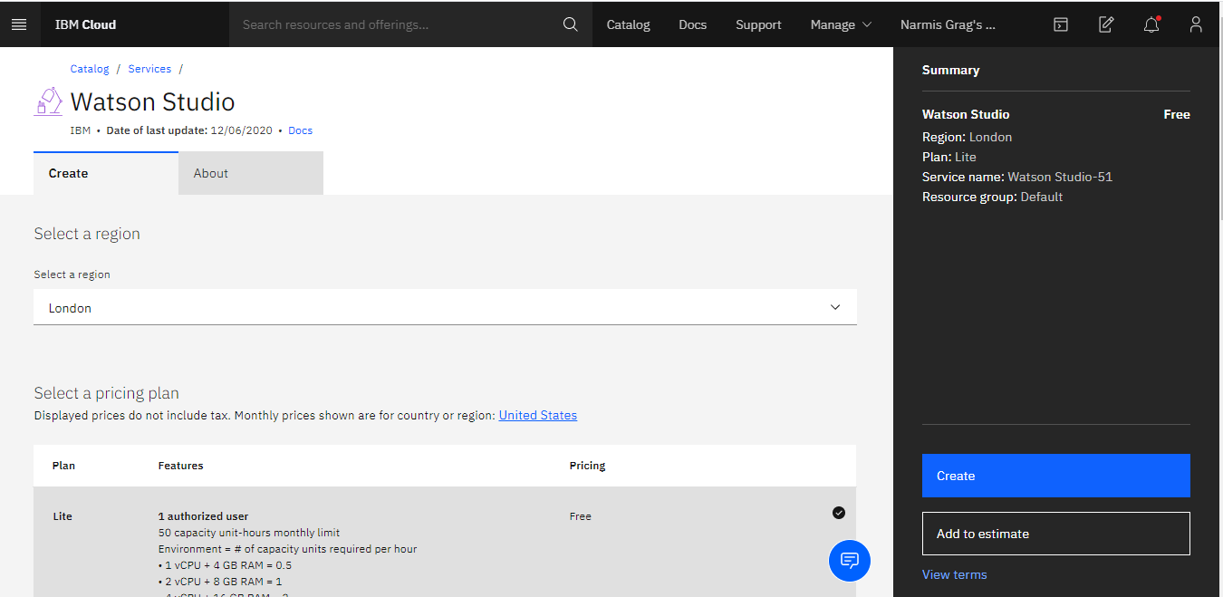

1. Now click **Launch IBM Cloud Pak for Data**.

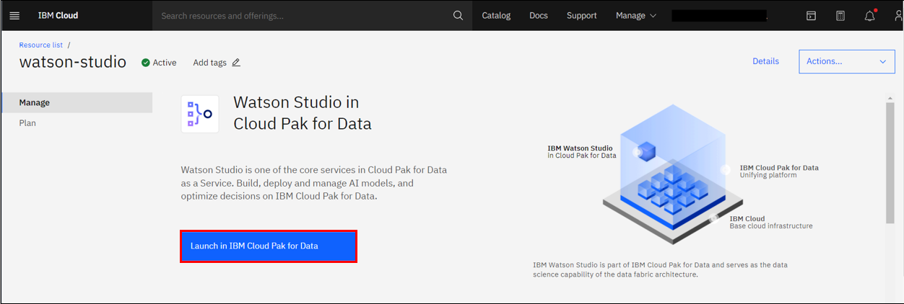

1. Then click **Go to IBM Cloud Pak for Data**.



1. Then click **Continue**.

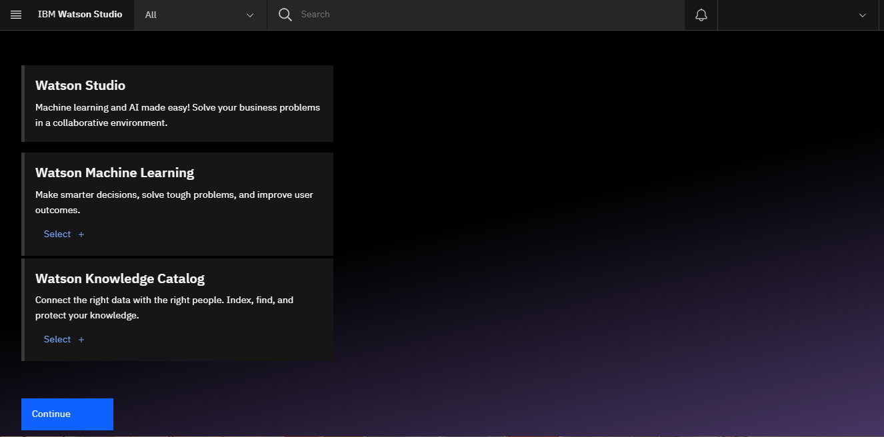

**Task 2: Open Watson Studio**

1. Go to the [Resource list](https://cloud.ibm.com/resources?utm_medium=Exinfluencer&utm_source=Exinfluencer&utm_content=000026UJ&utm_term=10006555&utm_id=NA-SkillsNetwork-Channel-SkillsNetworkCoursesIBMDeveloperSkillsNetworkDS0105ENSkillsNetwork984-2022-01-01) and click on the drop-down arrow for **AI / Machine Learning**.

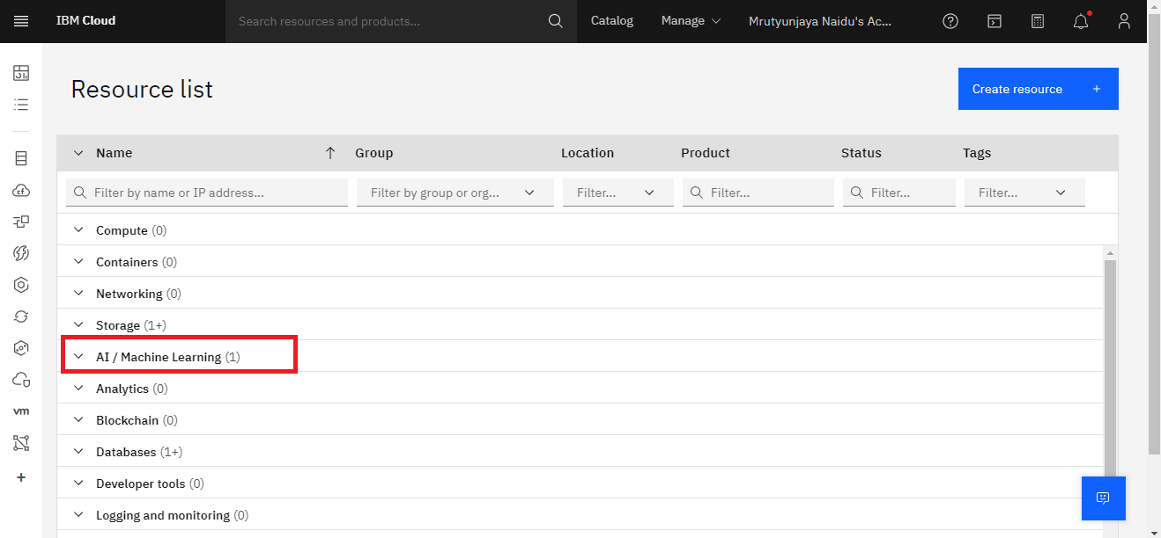

1. Under **AI / Machine Learning** you will find the Watson Studio which you just created. Click the Watson Studio service.

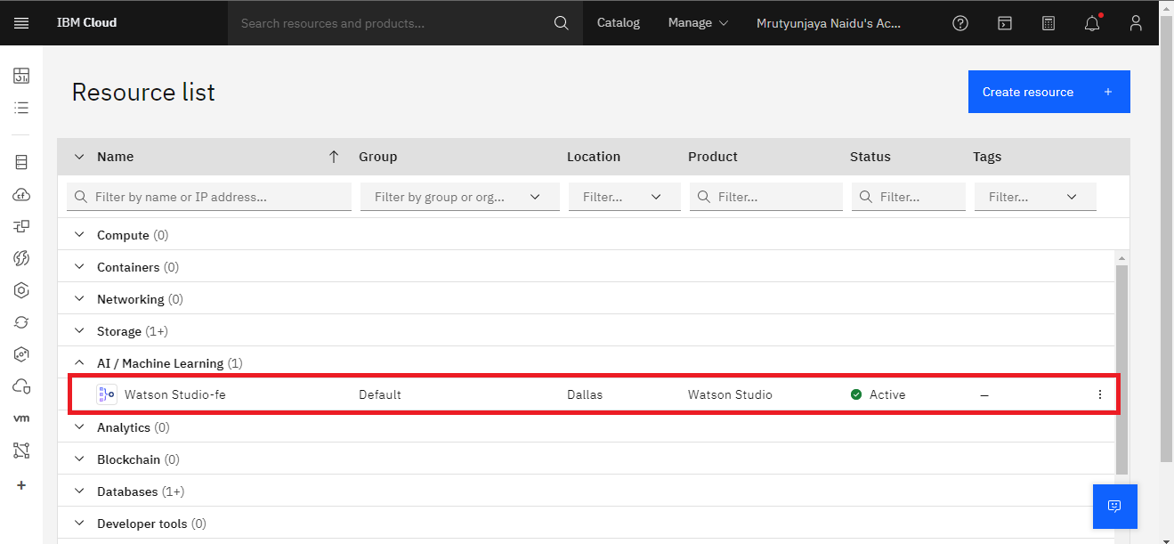

1. Then click **Launch IBM Cloud Pak for Data**.



**Task 3: Create a Project**

1. Click on **Create a project**.

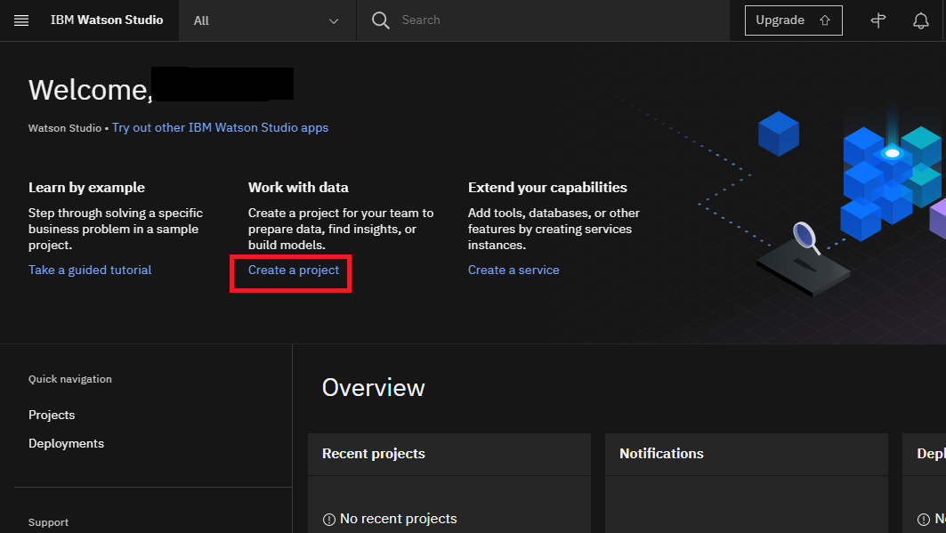

1. On the **Create a project page**, click **Create an empty project**.

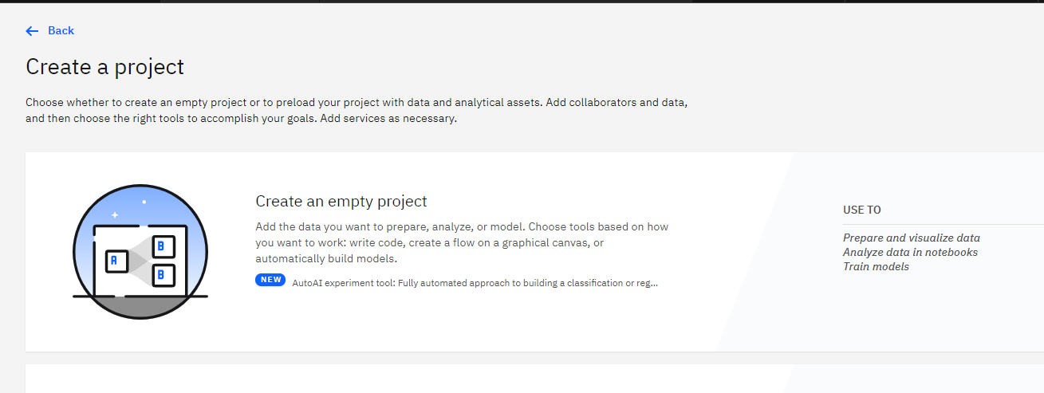

1. Provide a **Project Name** and **Description**.

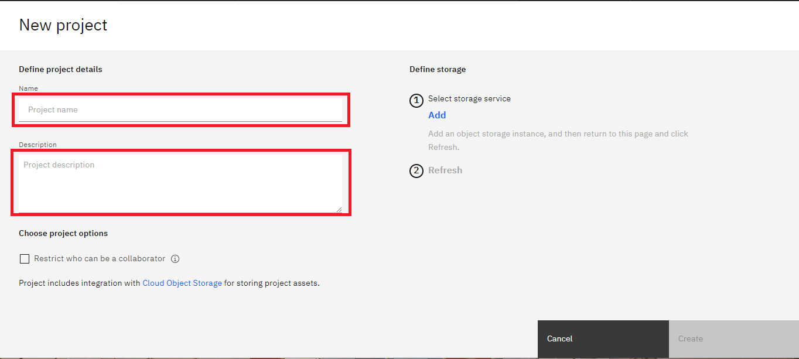

1. You must also create storage for the project. Click **Add**.

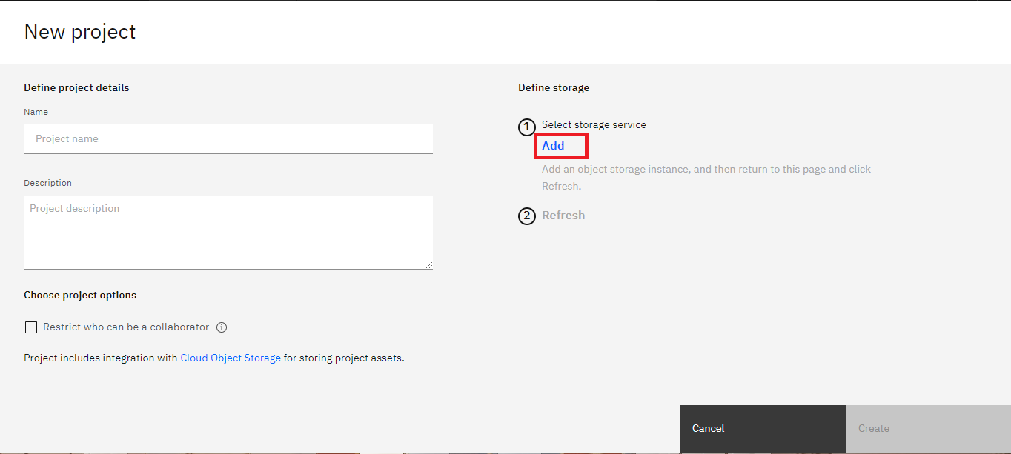

1. On the Cloud Object Storage page, click **Create**.

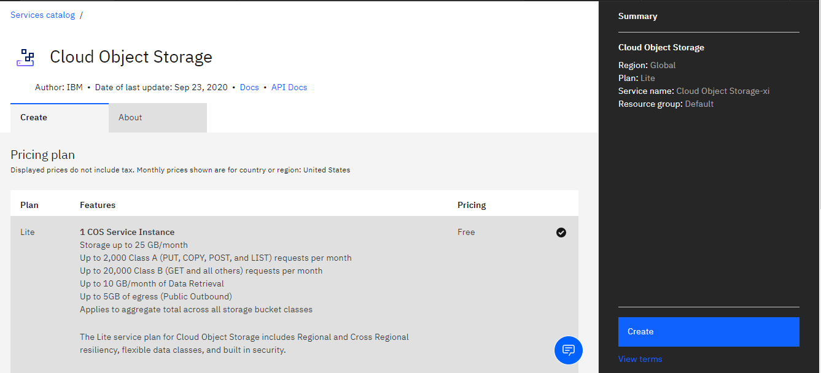

1. On the New project page, note that the storage has been added, click **Refresh** and then click **Create**.

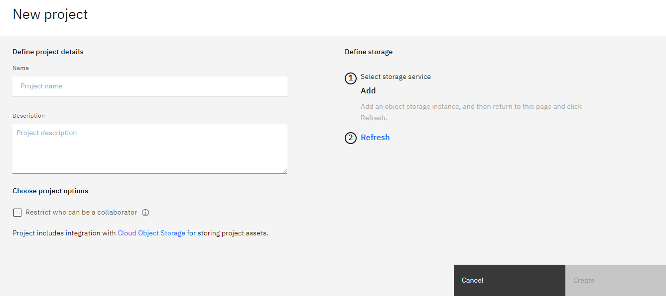

**Task 4: Adding a Notebook to the Project:**

1. Click on **Assets** > **New asset**.

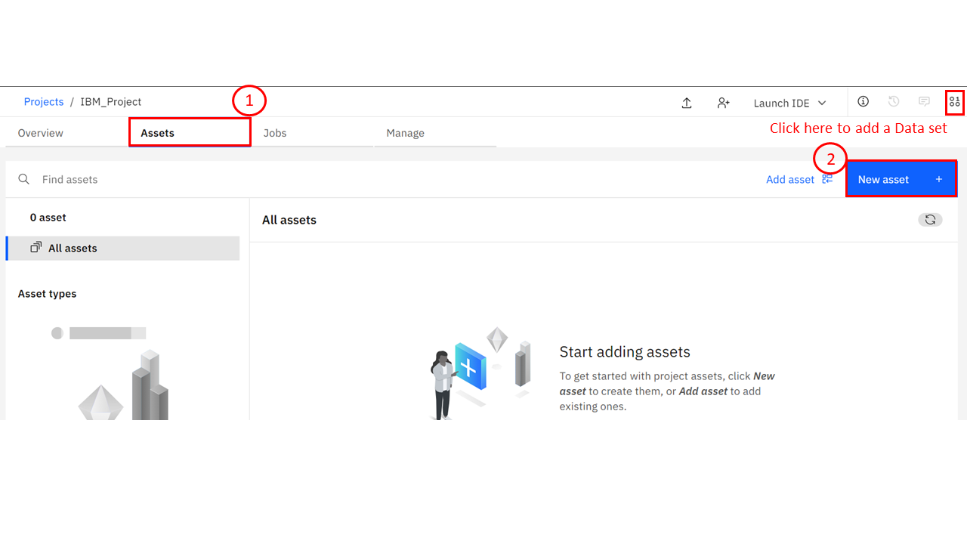

1. In the list of asset types, click **Jupyter Notebook Editor**.

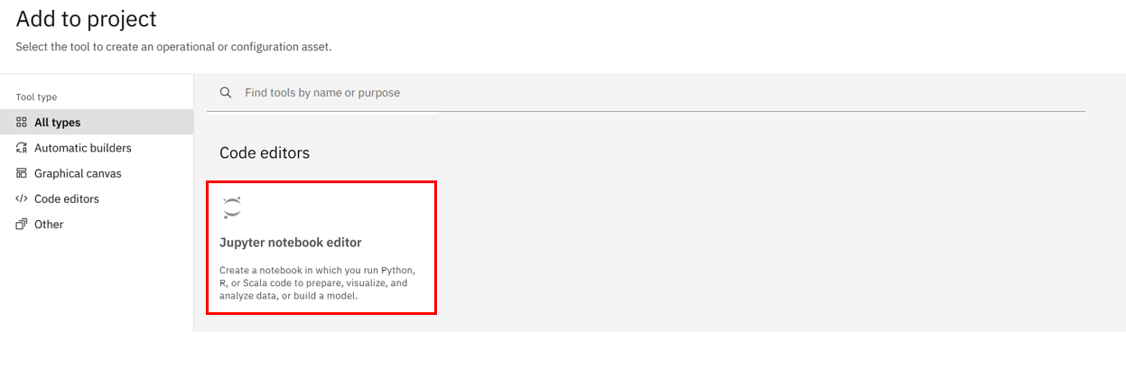

1. On the New notebook page, click **Blank** and then add a name and optional description for the notebook. Specify the language as Python and runtime environment. Click **Create**.

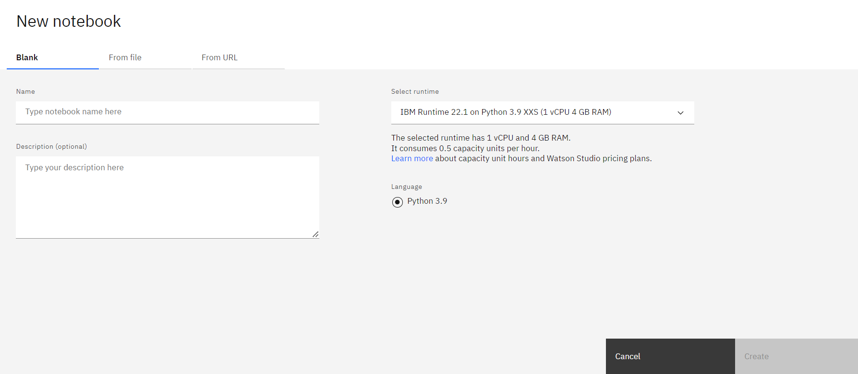

*Wait until the notebook appears. If you are interested, the Jupyter enterprise gateway has requested resources on the Kubernetes cluster IBM hosts for serving the Jupyter kernel backing your notebook.*

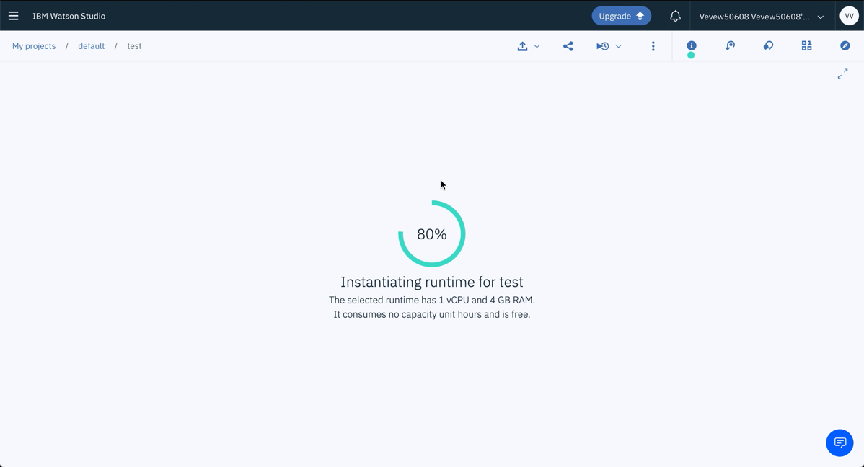

Now you are ready to code!

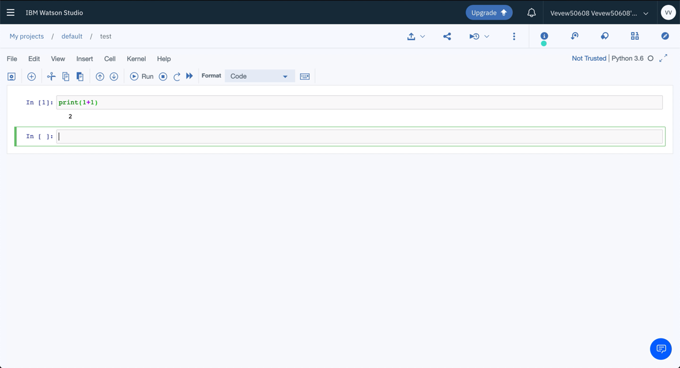

This concludes this tutorial.

**Linking GitHub to Watson Studio**

Welcome to “Linking GitHub to Watson Studio.” After watching this video, you will be able to

describe how to connect a Watson Studio account with GitHub, and describe how to publish Watson Studio notebooks on GitHub. You know how to create a new project and notebook. So, let’s open your project and find the Data Science Notebook you created in a previous module. To integrate Watson Studio to GitHub, click Manage, then on the left panel, under Project, click Service & Integrations.

Next, in IBM services, select Third-party integrations, and then click Connect integration. In Connect Integration, to establish the connection, select GitHub and click Next. Click the personal access token hyperlink to create the new access token. Log in to your GitHub account by entering your Username and Password. Then click Sign in. To create a new personal access token, provide the description of the token. To define the access for personal tokens, under Select scopes, select repo. Next, ensure gist is selected and click Generate token.

In the Personal access tokens page, copy the generated access token by clicking the copy icon.

Now, go back to the Connect Integration area and add the generated token. Next, you must find the repository URL for the location you want to push the notebook. To get the repository URL from GitHub,

ensure you are in the master branch of the repository you want to use. Click Code and copy the URL using the copy icon. Go back to the Connect Integration area and enter the repository URL where you want to push the notebook. Then click Connect. Once the repository is added, you get a successfully connected message. Now you can go back to the Assets tab and select the notebook you want to push to GitHub. Once the notebook is open, on the top right, select the down arrow and click Publish on GitHub. On the Publish on GitHub page, select All content except hidden code cells. Then click Publish.

A successful publish message will pop up with the name of the notebook file and repository. In GitHub, you can see the notebook, Data Science notebook.ipynb, which confirms that you published your notebook from Watson Studio.n this video, you learned that Watson Studio accounts can be integrated into GitHub, and you can push notebooks from Watson Studio to GitHub.

## Assignment using Watson Studio

**Effort: 20 mins**

### Objective:

In this final assignment, you will be able to:

1. Create a blank Jupyter Notebook in the Watson Studio environment.
2. Create Markdown cells.

## Instructions

This course introduced you to multiple data science tools, and in this final project, you will use the Jupyter Notebook, one of the easiest tools to share publicly.

## Exercise 1: Create a blank Jupyter notebook in the Watson Studio environment

* Log in to your IBM cloud account and launch the Watson studio.
* Create a new project and add a new asset as **Jupyter Notebook editor**.
* Create a blank notebook.

## Exercise 2: Create Markdown cells

* **Cell 1 (rendered as Markdown)**: The title should be “My Jupyter Notebook on IBM Watson Studio”, in H1 header style. The title is not center aligned.
* **Cell 2 (rendered as Markdown)**: Include your name, in bold. In the next line, write your current or desired occupation in regular font.
* **Cell 3 (rendered as Markdown)**: In italics, write one or two sentences about why you are interested in data science. For example, you can start your first sentence with “I am interested in data science because…”.
* **Cell 4 (rendered as Markdown)**: In H3 header style, describe your code in Cell 5 using a few short sentences.
* **Cell 5 (code cell)**: Enter your code, as described in Cell 4. It must be executed and must display an output. Try to keep the code simple (it can even be “1 + 1”).
* **Cell 6 (rendered as Markdown)**: Using Markdown or HTML, this cell must include at least three of the following: bulleted list, numbered list, tables, hyperlinks, images.

### Steps to complete the assignment in Watson Studio

**Leveraging Jupyter Notebook on the IBM Watson Studio, you will create your own Jupyter Notebook (in English) and share it via a public link.**

**How to generate a publicly viewable share link for your Jupyter Notebook:**

**Step 1.** With a Jupyter Notebook open on Watson Studio, first ensure that you save the notebook. Click **File**, and select **Save Version**,as shown below.

How to generate a publicly viewable share link for your Jupyter Notebook:

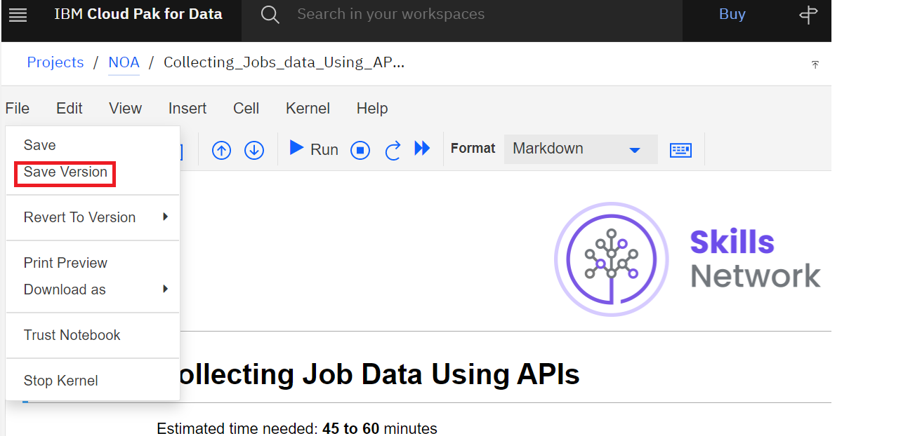

**Step 2.** Click the **Share** button, as follows:

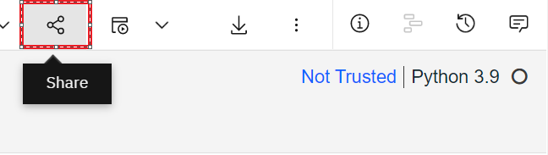

**Step 3.** Select the following settings to retrieve a public link to your Jupyter Notebook:

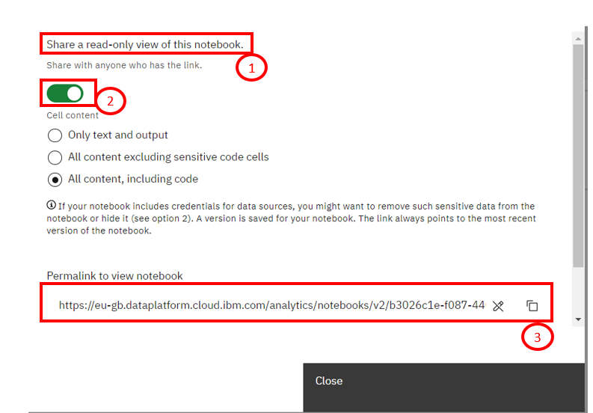

**SUMMARY**

Congratulations! You have completed this module. At this point in the course, you know:

* Watson Studio is a helpful tool for:
  + Analyzing and viewing data
  + Cleaning and shaping data
  + Embedding data into streams
  + Creating, training, and deploying
* Learning Watson Studio promotes career growth.
* Learning Watson Studio is easy and requires no special skills.
* Watson Studio offers many available resources.
* You must create an IBM Cloud account to use Watson Studio.
* You can open Watson Studio by clicking Catalog on the IBM Cloud dashboard and then AI/Machine Learning.
* You can create an empty project or a project from a sample or file by selecting the Work with data option.
* You can add a storage service by clicking Add and then selecting the storage service of your choice.
* You can add or create a new notebook by clicking **New asset** on the project home page under the **Assets** tab.
* You can share your notebook without sharing the sensitive cells.
* Jobs are created and scheduled from the **Create a job** icon in the notebook action bar.
* Jobs can be viewed, edited, or deleted on the project home page under the **Jobs** tab.
* Jupyter Notebook runtime environments and templates can be found on the Environments tab in the Home Page.
* You can create and change new Jupyter Notebook templates.
* Watson Studio accounts can be integrated into GitHub.
* You can push notebooks from Watson Studio to GitHub.